**Squirrels Maths**

**Year 1 and 2**

Here is a four by four dotty grid:  
  
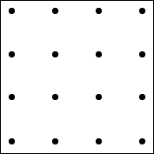  
  
I have joined three dots on the grid to make a triangle which has one dot inside it:  
  
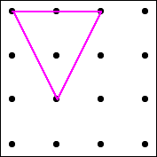

How many different triangles with one dot in the middle can you draw?

How do you know have found them all? Could you use different coloured pencils to draw your triangles so it’s easy to count them later?

You could print off or draw these dotty grids to work on.

Have you answered all of the above questions?



