**Topic:**

Hello Foxes,

You have leant about how the ‘War of the Roses’ occurred and about Henry VIII and his 6 wives. Now we are going to look in more detail at how the other side of the Tudors lived – The Tudor Peasants.

In this session, we are going to compare the ‘Clothing’ of Tudor Lords and Tudor Peasants.

**Activity – Green / Red / Blue**

1. Read through the PowerPoint named ‘Tudor Clothing.’
2. Then below, choose either a Tudor Lord to compare with a Male Tudor Peasant or a Tudor Lady to compare with a Female Tudor Peasant.
3. Label both of them with the help of the PowerPoint and then pick your colour below.

Green

Choose two parts of the Tudor Lord/Ladies and the Tudor Peasants that are different and compare them in full sentences.

E.g. The Tudor Lady wears a ‘French Hood’ however the Tudor Peasant wears a ‘Rough Cotton Cap.’

Red

Choose three parts of the Tudor Lord/Ladies and the Tudor Peasants that are different and compare them in full sentences.

E.g. The Tudor Lady wears a ‘French Hood’ however the Tudor Peasant wears a ‘Rough Cotton Cap.’

Blue

Choose two parts of the Tudor Lord/Ladies and the Tudor Peasants that are different and compare them in full sentences.

E.g. The Tudor Lady wears a ‘French Hood’ however the Tudor Peasant wears a ‘Rough Cotton Cap.’

Tudor Lord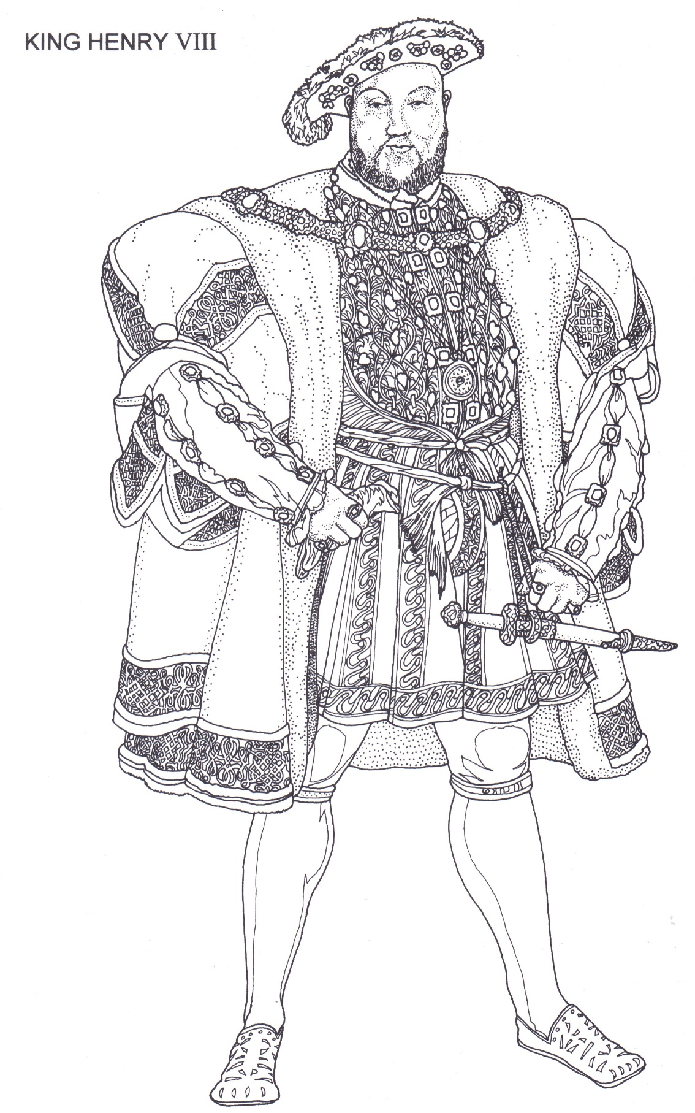

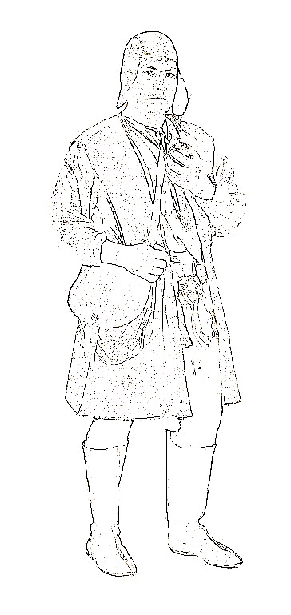Male Peasant:

Tudor Lady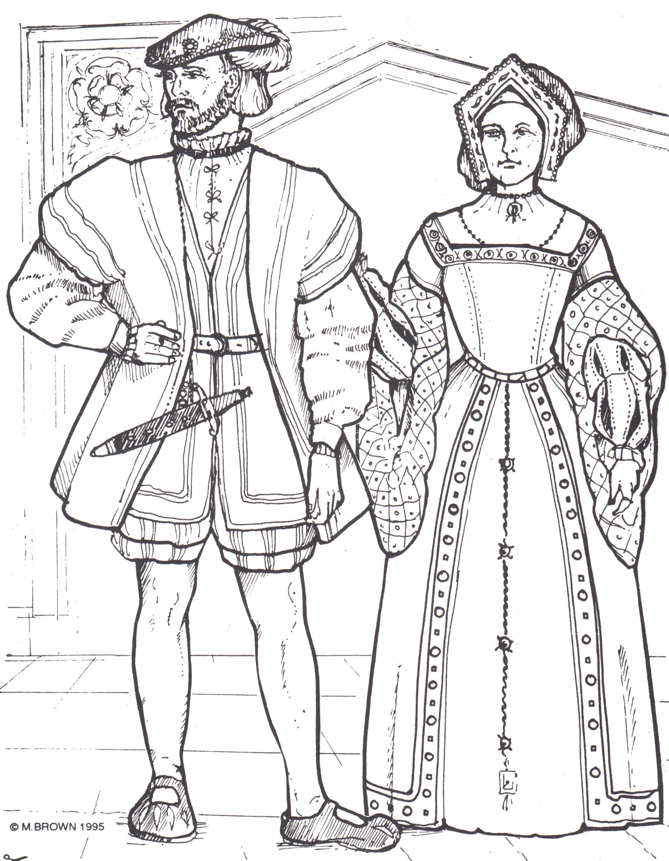



Female Peasant 