Maths 3.6
Go to the following website:
https://whiterosemaths.com/homelearning/year-3/
Watch the video Tenths as decimals and have a go at answering any questions.
Have a go at these. If you can do A easily have a go at B
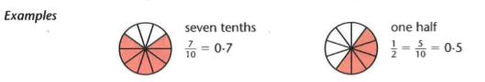
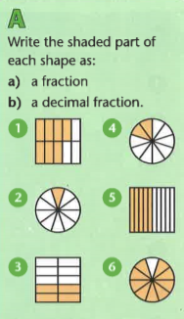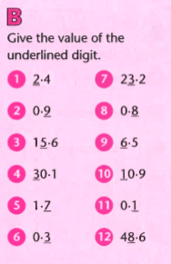
Challenge
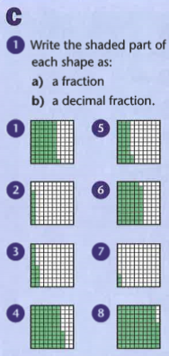
Answers

