Maths 3.6

Go to the following website:

<https://whiterosemaths.com/homelearning/year-5/>

If you understand, try the work sheets below.

If you are still unsure watch the following video…

<https://www.bbc.co.uk/bitesize/articles/z6ghscw>

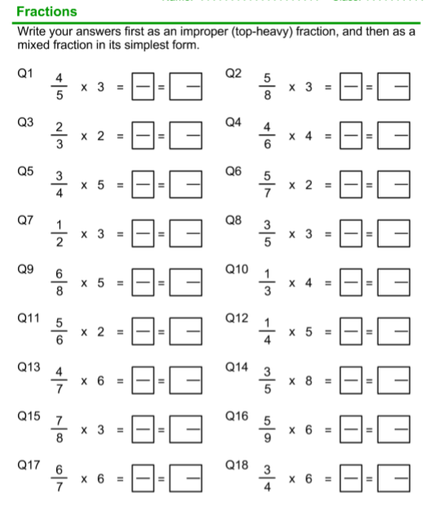

**Why not try some challenge questions. The answers are below.**

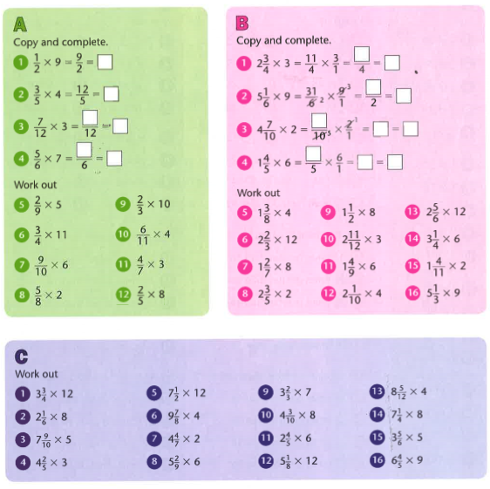

Answers

