Squirrels – English
Year 1
Here is a link to the story, ‘Strictly No Elephants’. Listen to the story now. https://www.youtube.com/watch?v=_0yJOKdvRrg
Pause the video when you reach the page below. Have a good look at the image below then read the following questions which will guide your thoughts. 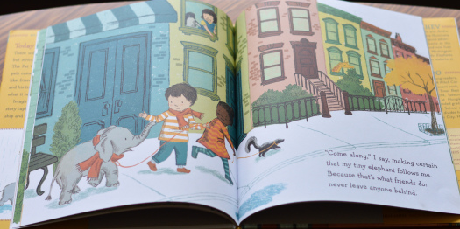
What do you notice? Where is this place? Is it a town or a village? Think of reasons for your choice.
What time of the year do you think this is? How can you tell?
Look at the houses and windows. What do you see?
Look at the characters, who are they, what are they wearing? What do you know about them?

Activity
I would like you to collect all the words that describe this picture. Remember to use your senses. Imagine if you were there, what would you see, hear, feel or smell? We don’t need to use our sense of ‘taste’ in this task. Record the adjectives (describing words) on your sheet.

Some examples are
Tidy, peaceful street
Colourful, large windows
Breezy autumn day

Challenge
Write a description
Can you write a description of what you see in the picture using the ideas you have collected above?

