Squirrels – English
Year 1
Here is a link to the story, ‘Strictly No Elephants’. Listen to the story now. https://www.youtube.com/watch?v=_0yJOKdvRrg
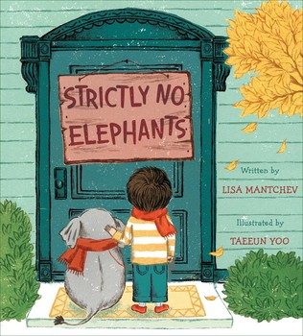

Activity
Now retell the story in your own words to an adult.

Challenge
Write the blurb
The blurb is the text on the back cover of the book. It is a summary of the story. It is there to get the reader interested in the story but never gives away the ending!

I noticed this book didn’t have one. Could you write a blurb for our story? You can add an eye-catching illustration to make the reader even more interested if you like.

Example of a blurb for Strictly No Elephants:

When the local Pet Club won't admit a boy's tiny pet elephant, he finds a solution-one that involves all kinds of unusual animals in this sweet and adorable picture book.
Today is Pet Club day. There will be cats and dogs and fish, but strictly no elephants are allowed. The Pet Club doesn't understand that pets come in all shapes and sizes, just like friends. Now it is time for a boy and his tiny pet elephant to show them what it means to be a true friend.

