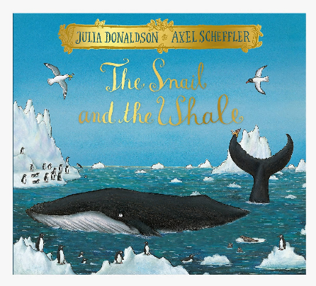
Year 2- English

Over the next few weeks, we are going to read the story The Snail and the Whale by Julia Donaldson. We will be using this book for some of our English lessons. I love this book and I hope you enjoy it too.

You can listen to this story on YouTube - https://www.youtube.com/watch?v=EmMnaSkeKqQ
(Make sure you have an adult with you when you are watching videos on YouTube and stay safe on the internet, if you need a reminder on how to stay safe online, take a look here- https://www.bbc.co.uk/bitesize/topics/zymykqt/articles/zym3b9q )

Alternatively, if you have this book at home, sit back, relax and enjoy reading this book to yourself or with an adult at home.

Book Talk
Before you begin to read this story, take a good look at the front cover (see above) and talk or think about what you can see. Can you identify all the animals in the picture?
If the characters/ animals were speaking what might they say?
Who do you think the main characters are?
What do you think will happen in this story?
Does this remind you of any other stories you know?
What questions do you have about what is happening?

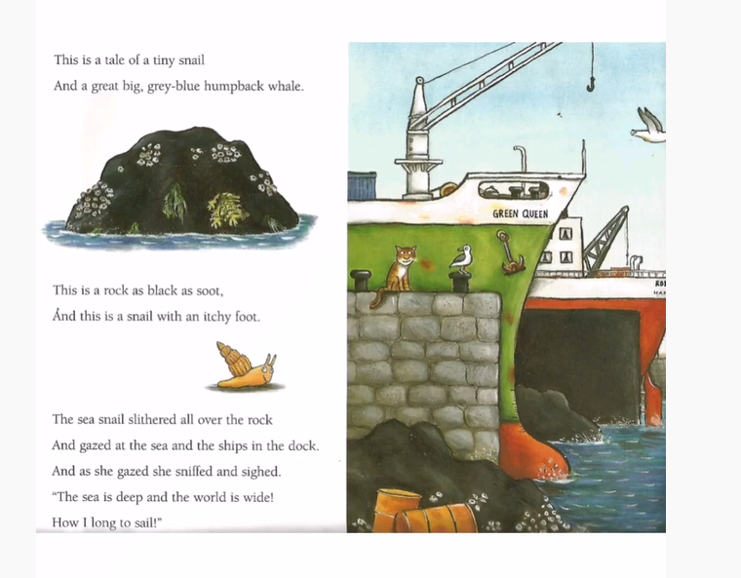
Read the beginning of the story.
Look back at the phrase ‘This is a snail with an itchy foot.’ What does this mean? Look at the clever use of idiom here; the snail’s underside is called its foot and the idiom to get itchy feet means to want to travel or do something different. Why do you think she wants to travel? Where do you think she might like to go?

Allow yourself some time to imagine where the snail dreams of travelling. You may want to use some of your own experiences of travelling or talk to some adults for inspiration.

Task: Draw a picture of the snail with a large thought bubble and write down her ideas and thoughts of where she dreams of travelling.

Remember to use interesting language and you can be as adventurous as you like.

What you need to be successful:
Wow words: glistening, magical, crystalized, colourful, ecstatic
Golden rules: capital letter, finger space, full stop
Interesting sentence openers:
Ecstatically, I would ride the waves….
Just ahead, colourful….

Challenge
Can you Rewrite the beginning of the story in your own words? Try and change the adjectives, verbs and simile that the author has used.

