Year 2 – English
Look at the picture below.
Can you write a paragraph to describe it?
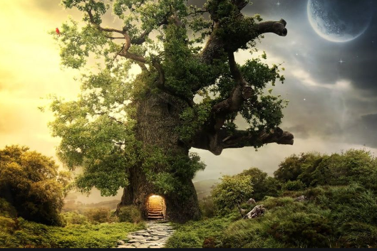
Remember to use interesting language and you can be as imaginative as you like.
To engage the reader, you need to use lots of exciting adjectives and verbs in your writing (see the links below). Interesting sentence openers will make your writing even more exciting to read.
https://www.bbc.co.uk/bitesize/topics/zrqqtfr/articles/zy2r6yc
https://www.bbc.co.uk/bitesize/topics/zrqqtfr/articles/zpxhdxs
What you need to be successful:
Wow words: glistening, magical, crystalized, colourful, glimmered
Golden rules: capital letter, finger space, full stop

Challenge
Can you use similes or/and a metaphor in your writing?
https://www.bbc.co.uk/bitesize/topics/zfkk7ty/articles/z9tkxfr

