Year 3 Maths:
Hello Year 3s,
This week we are going to be focusing on ‘Place Value.’ Please follow the link below and watch the videos. The work is a mastery sheet on place value.
I have added them to this document and I have also added some Green, Red and Blue questions as a warm up.

Video Link: https://www.bbc.co.uk/bitesize/articles/zmdpnrd

Green:
- 28 + 32
- 64 + 17
- 120 – 10
- 136 – 24
5. ½ of 12
Red:
- 422 + 146
- 273 + 176
- 170 – 20
- 1982 – 341

Blue:
- 12,365 + 24,387
- 32,572 + 24,502
- 78,652 – 16, 441
- 26,172 – 13,062
- ¾ of 12
Starter:

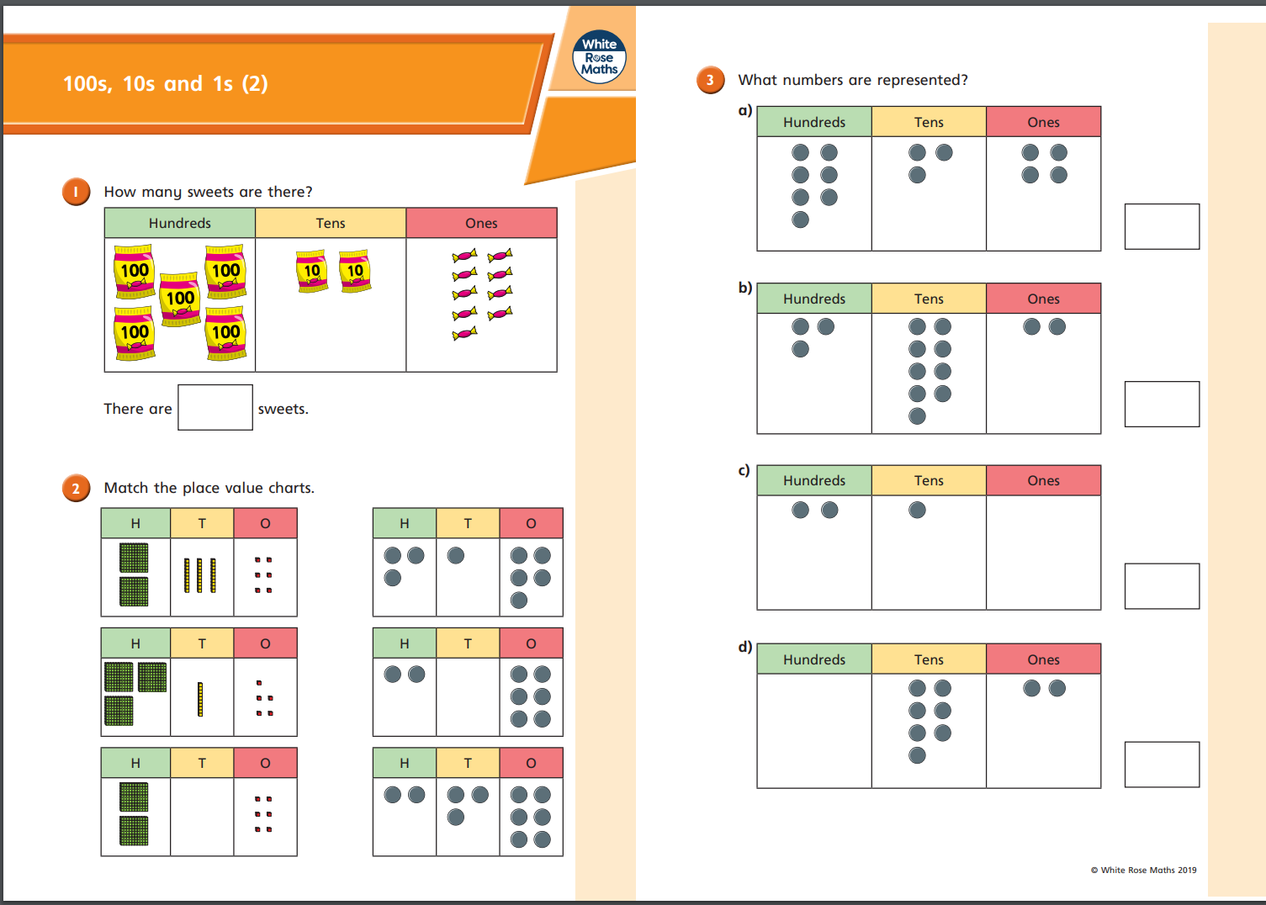
Activity 1:
