Year 3 Maths:
Hello Foxes,
Today you will be learning about ‘Comparing Three-Digit Numbers.’
Please follow this link: https://www.bbc.co.uk/bitesize/articles/zhpq7nb
- Follow through the ‘Learn’ section of the page.
- Please complete ‘Activity 1’ which is below.
- Please do not complete Activity 2 from the website but complete the other activity which is below in ‘Green, Red and Blue.’

Activity 1:
Please use this link as the dice: https://www.random.org/dice/
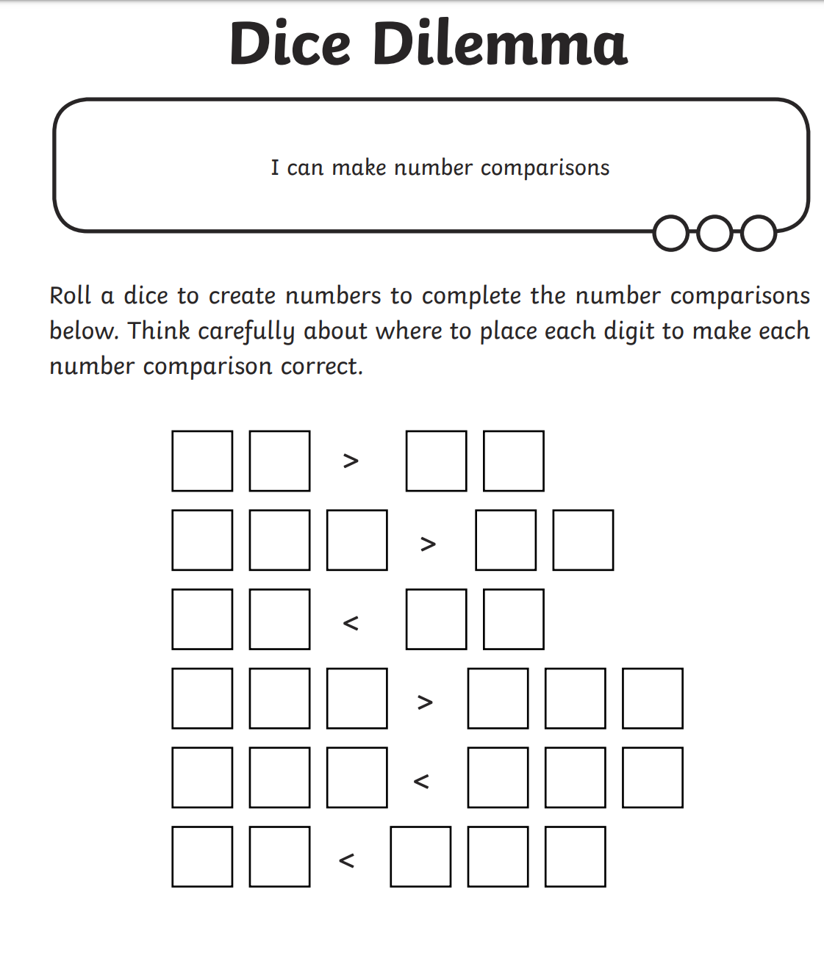

Activity 2:
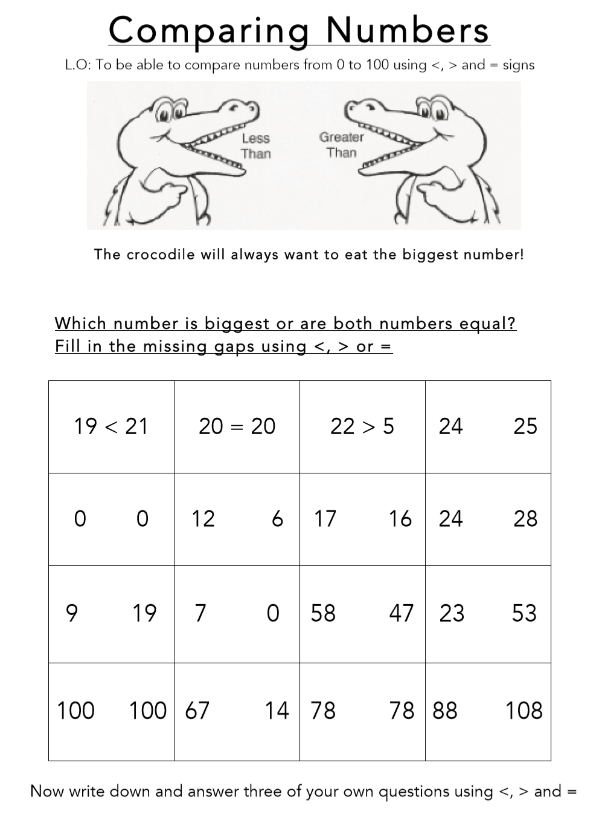
Green:

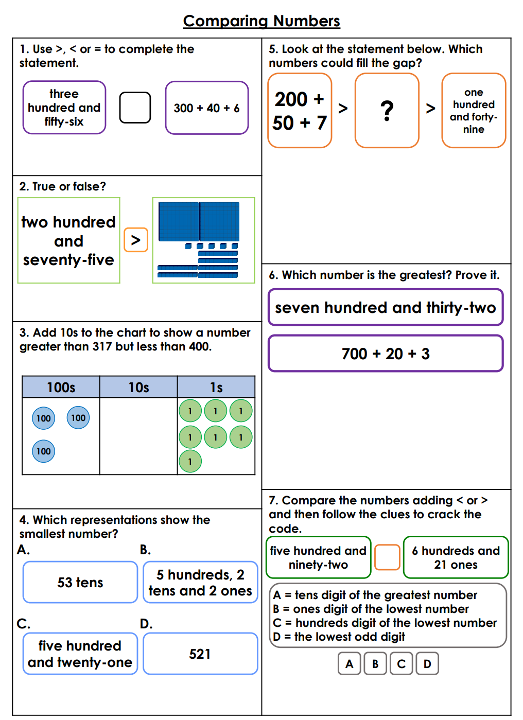
Red/Blue

