Year 4 Maths
Hello Year 4,
This week we are going back to basics and looking at Place Value using Maths Mastery.
Please follow the link and work through the activities given. Below there are some Green, Red and Blue warm up questions and then some maths mastery on Place Value. Please take your time to work through these.
Video Link: https://www.bbc.co.uk/bitesize/articles/zhnrcqt

Green:
- 28 + 32
- 64 + 17
- 120 – 10
- 136 – 24
5. ½ of 12
Red:
- 422 + 146
- 273 + 176
- 170 – 20
- 1982 – 341

Blue:
- 12,365 + 24,387
- 32,572 + 24,502
- 78,652 – 16, 441
- 26,172 – 13,062
- ¾ of 12

Starter:
1.

2.

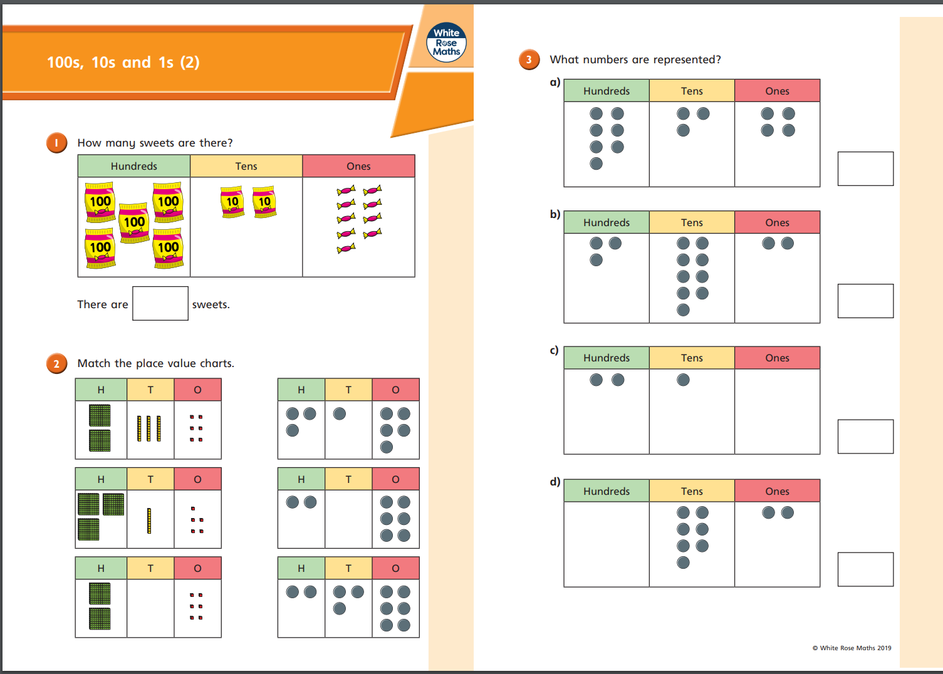
Activity 1:
