Year 4 Maths:
Hello Foxes,
Today we are going to be finding 1000 more or less.
Please follow the link: https://www.bbc.co.uk/bitesize/articles/zd9hpg8
- Look through the PowerPoint in ‘Learn.’
- Activity 1 is optional
- Please complete Activity 2 (Blue)
- In addition to these activities, there is one more activity that is split into Green, Red and Blue to complete.

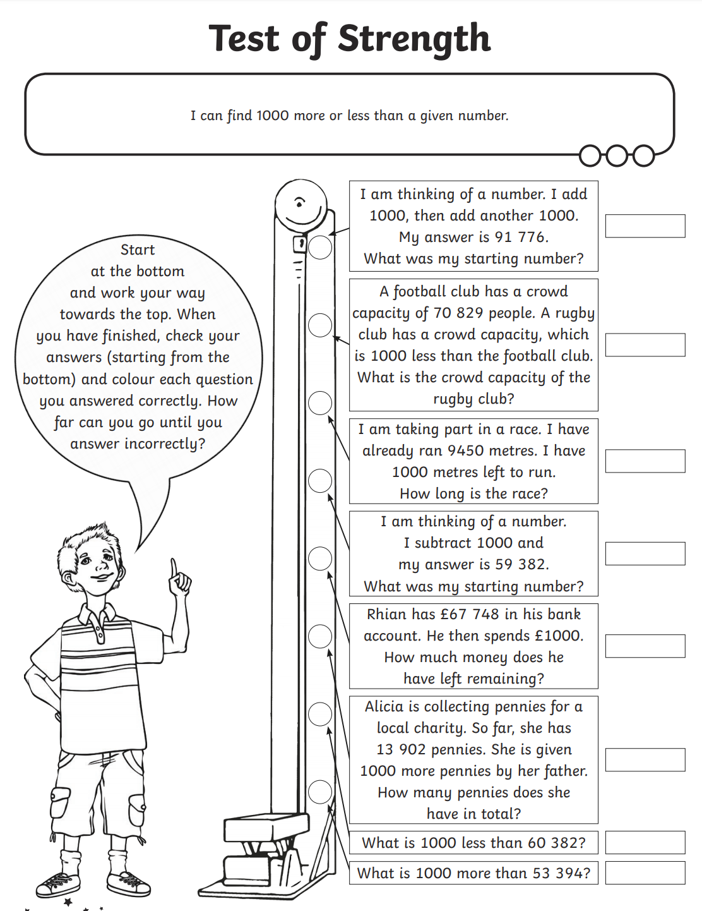
Activity 2: (Blue)

Activity 3:
Green/ Red/Blue
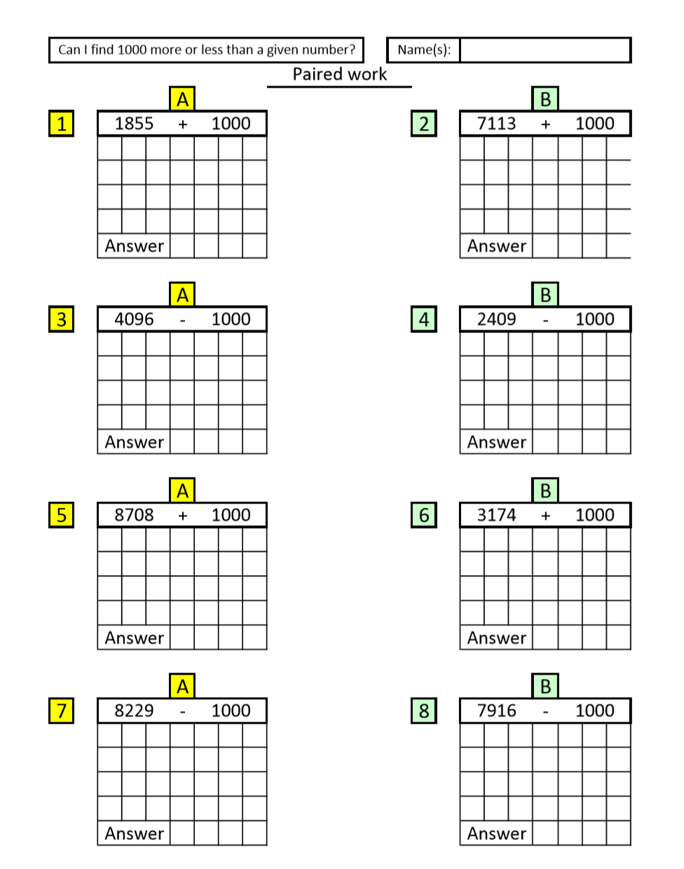

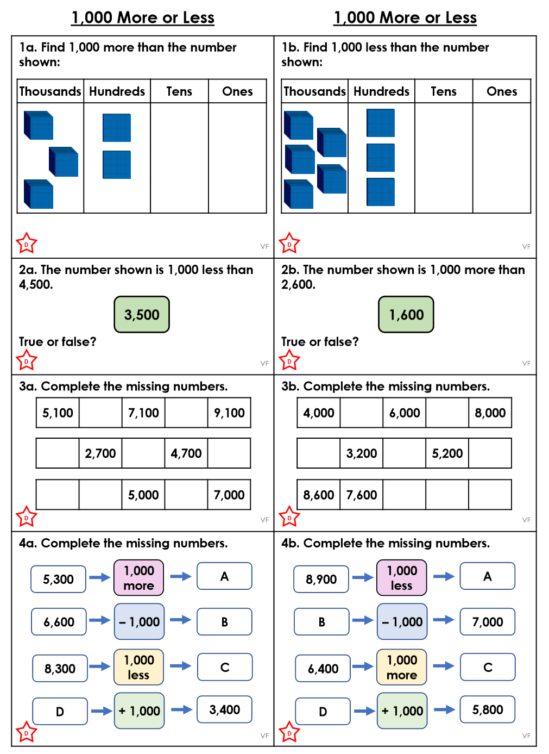
Green
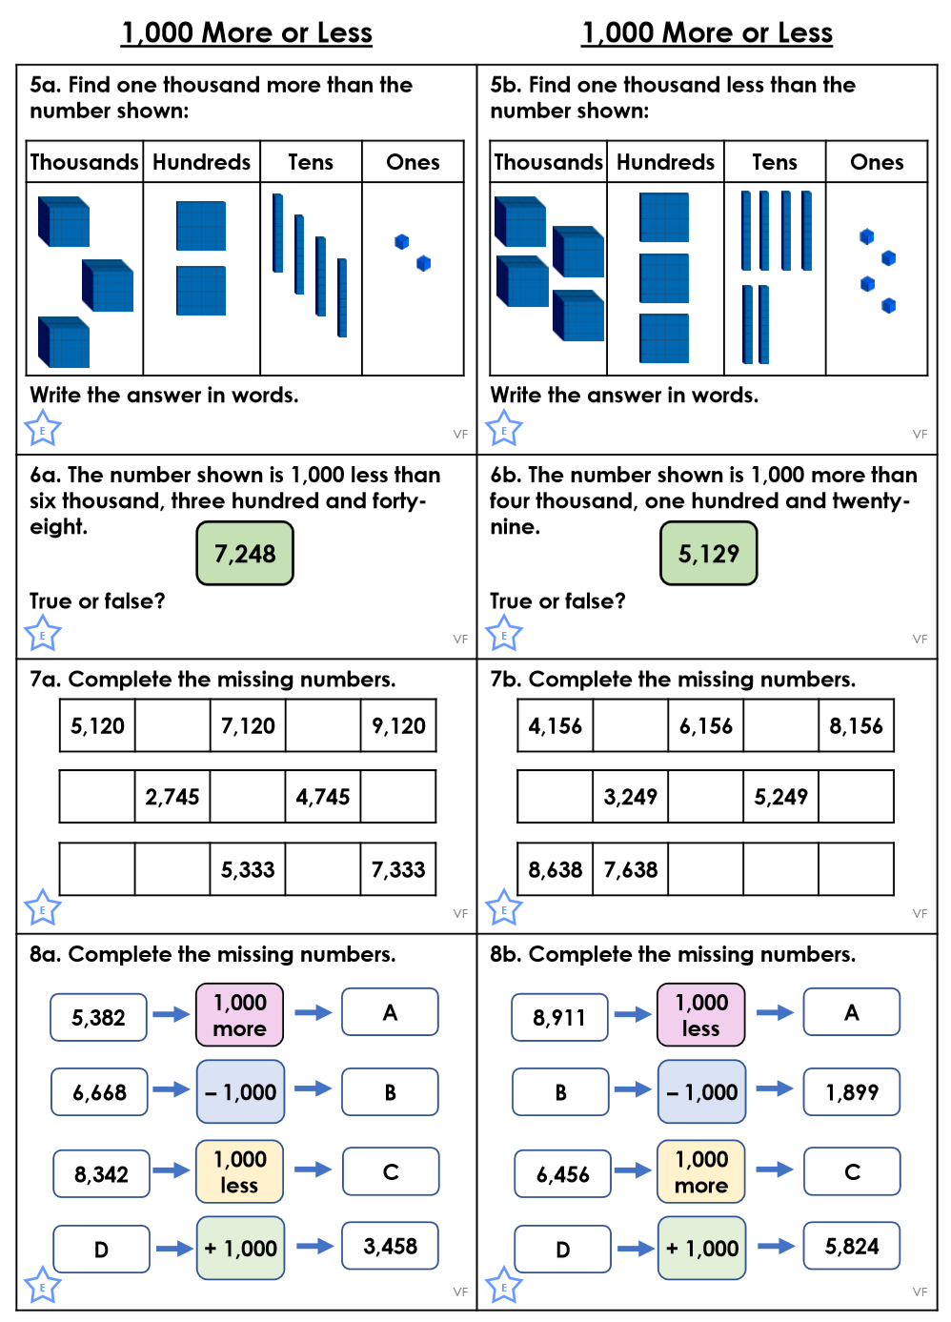
Red / Blue

