Maths 3rd June
Go to the following web page:
https://whiterosemaths.com/homelearning/year-6/
Go to week 1 lesson 2 equivalent FDP
Watch the tutorial.
Now go to the following website:
https://www.bbc.co.uk/bitesize/articles/zjckjp3
Watch the videos. Try the activity and the worksheet below.
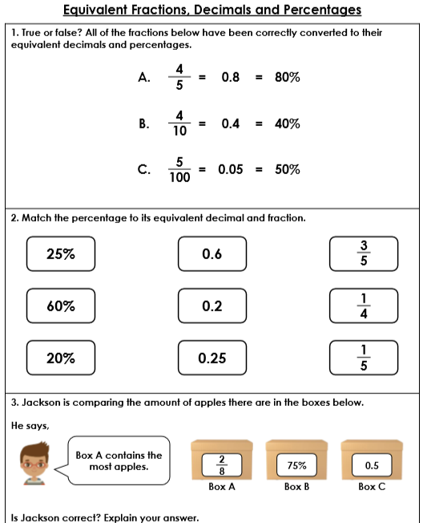

Check the answers below.

Answers
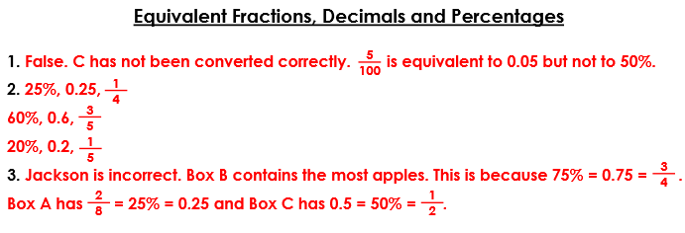

Challenge
