Charing CEP School
Living and learning with faith, friendship and fun
Charing School is an inclusive family, proud of our faith in God and our friendship with our community. We develop respect, aspiration, curiosity, tolerance and determination. We are a creative, compassionate and confident team.

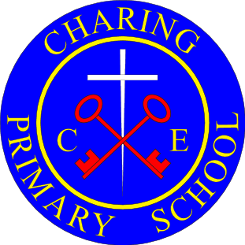

Progression of Skills Document

Progression of Skills in MFL/ International Speaker

Skills | Year R | Year 1 | Year 2 | Year 3 | Year 4 | Year 5 | Year 6
Spoken  Language |  | Join in with songs and rhymes  Respond to a simple command  Answer with a single word  Name people, places and objects | Answer with a short phrase  Ask an appropriate question  Use set phrases  Choose the right word to complete a phrase  Choose the right word to complete a short sentence | Name and describe people, places and objects.  Give a response using a short phrase | Have a short conversation saying 3-4 things  Start to speak in sentences | Hold a simple conversation with at least 3 exchanges | Use my knowledge of grammar to speak correctly
Reading |  | Read and understand single words | Read and understand short phrases  Use a simple dictionary to find the meaning of words | Read and understand a short passage using familiar language  Use a bilingual dictionary or glossary to look up words | Explain the main points in a short passage  Read a passage independently | Understand a short story or factual text | Use the context of a piece of writing to work out unfamiliar words
Writing |  | Write single words correctly  Copy a simple word | Label a picture  Copy a simple phrase | Write phrases from memory | Write 2-3 short sentences on a familiar topic  Say what I like/dislike about a familiar topic | Write 4-5 sentences | To substitute words and phrases

