Grammar Year 5 – Adding extra information
Go to the following web page:
https://www.bing.com/videos/search?q=parentheis+for+extra+meaning+ks2+video&&view=detail&mid=C6F547970AFDBFD3DFD6C6F547970AFDBFD3DFD6&&FORM=VRDGAR&ru=%2Fvideos%2Fsearch%3Fq%3Dparentheis%2Bfor%2Bextra%2Bmeaning%2Bks2%2Bvideo%26FORM%3DHDRSC4
Listen to the song and have a go at the grammar activities.
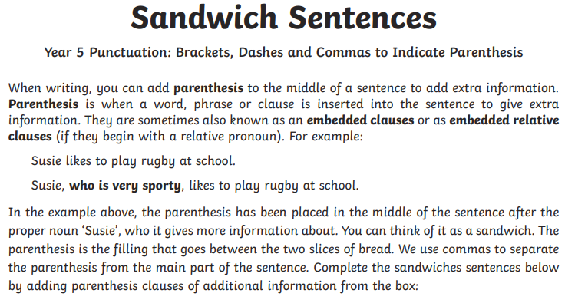
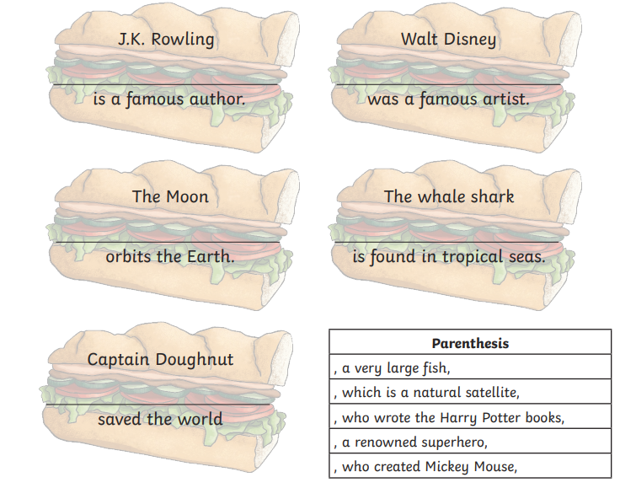
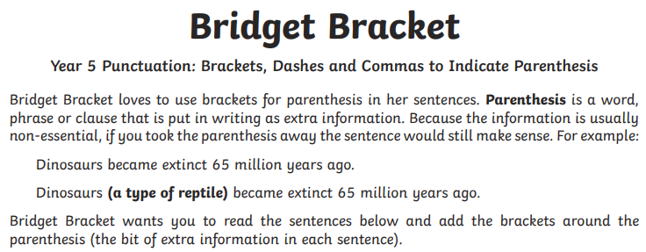
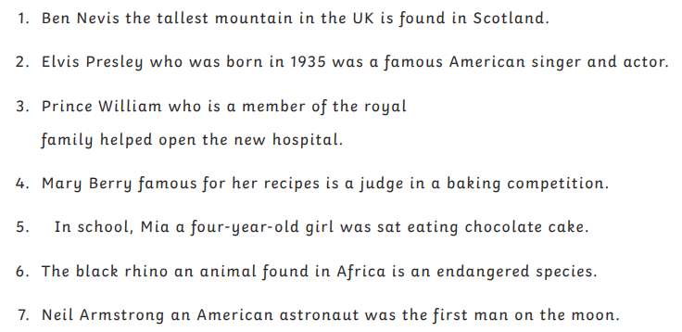

Make up three of your own sentences using brackets. Remember to add an interesting fronted adverbial.

