History Year 3 and 4
Go to the following web page: https://www.bbc.co.uk/bitesize/topics/zkrkscw/articles/zv2bmfr
Learn as much as you can about Henry VIII and try the interactive activity.
Can you correctly order Henry’s wives?
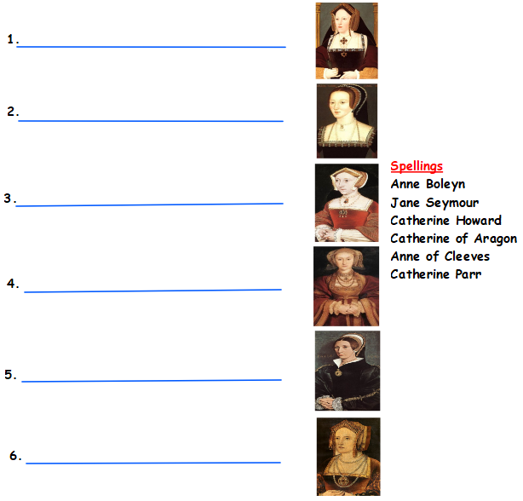

Clothes
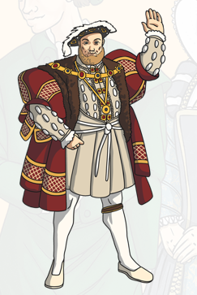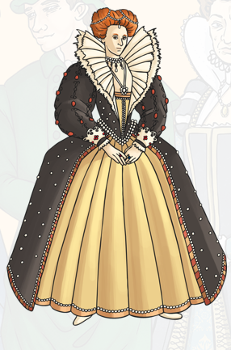
Are these rich Tudors or poor? How do you know?
How are their clothes different from the ones we wear today?

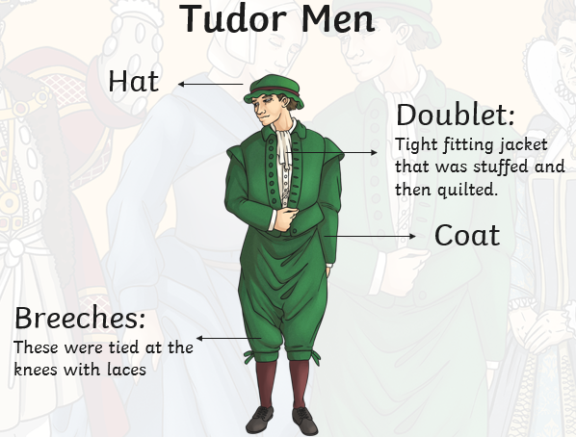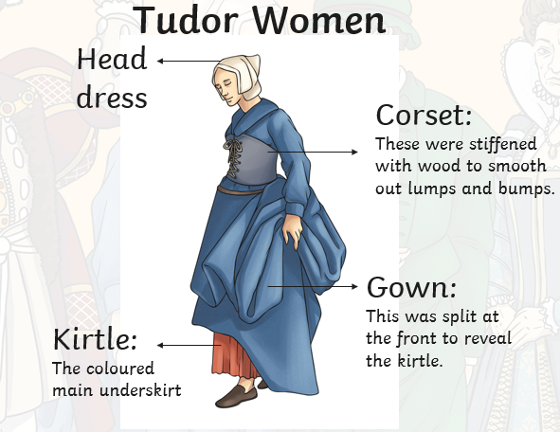
Are these rich Tudors or poor? How do you know?
Draw your own detailed drawing of either a rich or poor Tudor. Which would you prefer to wear? Why?
Try your own research. What can you find out about the Tudors?
Use the following websites to help you find out as much about the Tudors as you can.
https://www.bbc.co.uk/bitesize/topics/zsgkwmn/resources/1
https://www.dkfindout.com/uk/history/tudors/
Create a poster to show the information you have learnt.

