History Year 5
Famous Victorians – Mary Seacole
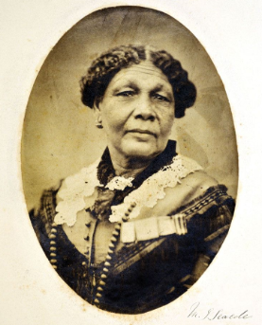
Activity 1
Use the following websites to research the life of famous Victorian, Mary Seacole.
https://www.bbc.co.uk/teach/class-clips-video/history-ks2-mary-seacole-ep1/z72prj6
https://www.natgeokids.com/nz/discover/history/general-history/mary-seacole/
https://kids.britannica.com/kids/article/Mary-Seacole/476315

Activity 2
Number these events in Mary Seacole’s life in chronological order.
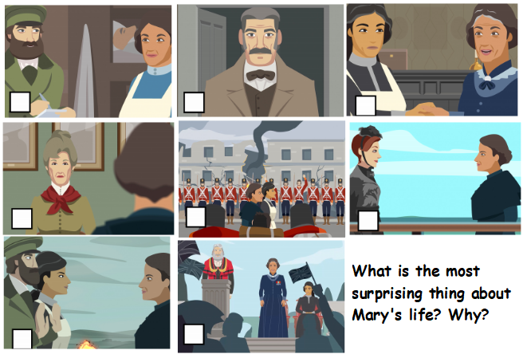

Activity 3
Use what you have learned about Mary Seacole to create a fact file about her. You can use the following format to help you.
