Maths Year 3/4
Measurement – length
Go to the following web page. Watch the video and choose the right questions for you. You don’t need to do them all.
https://www.bing.com/videos/search?q=measuring+length+year+3+white+rose&&view=detail&mid=C6B85CA2E7C923C3BB98C6B85CA2E7C923C3BB98&&FORM=VDRVRV
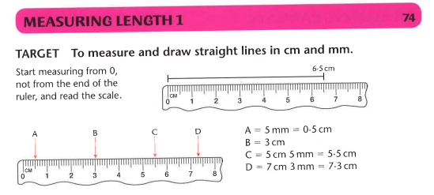
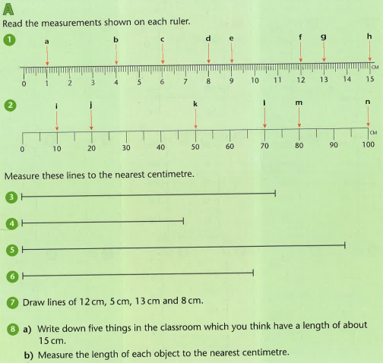

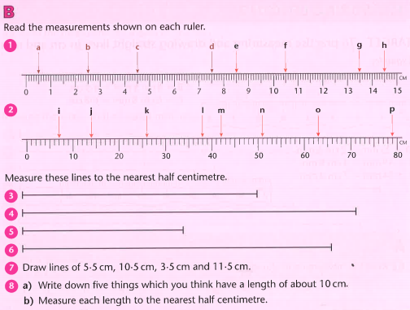
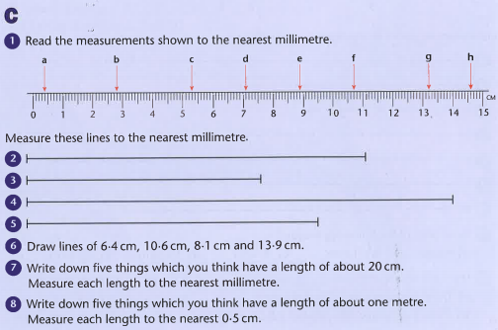

Find the answers below

