Maths Year 3 and 4
Try and do some from each section. You don’t need to do them all.
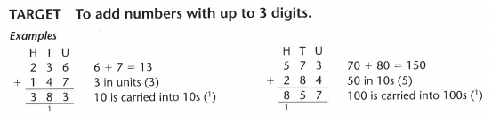
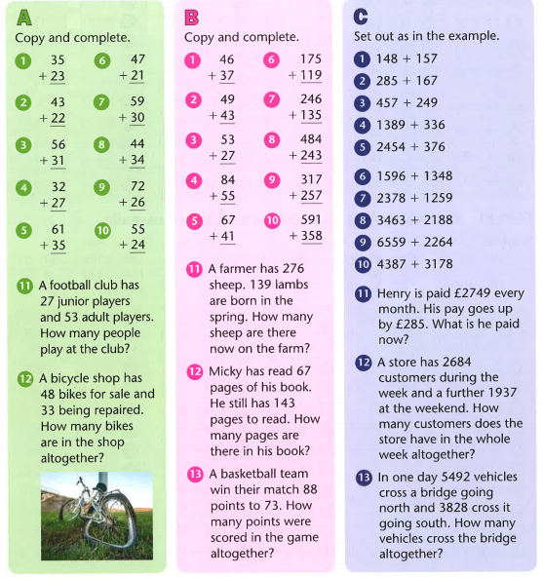

Find the answers below

