Maths Year 3 and 4
Calculations revision – You don’t need to do them all! Try a few questions from each section.
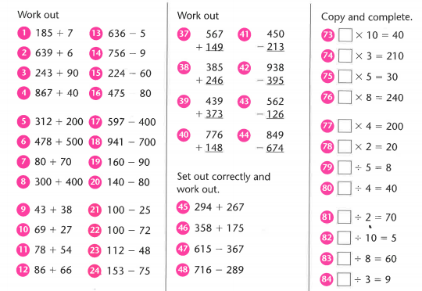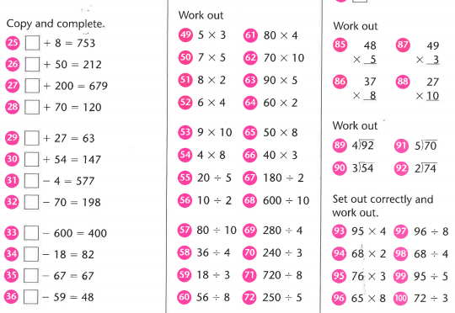
Find the answers below
