Maths Year 5
Try and do some from each section. You don’t need to do them all.
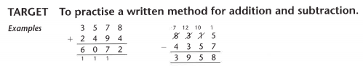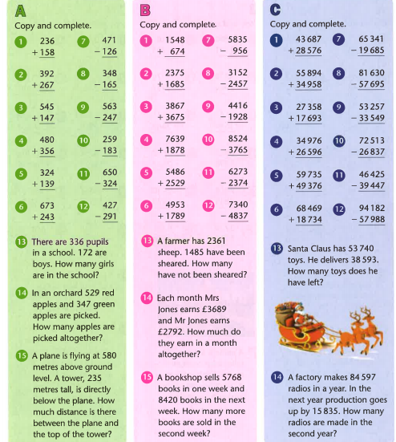

Find the answers below
