Maths Year 5
Angles – Go to the following web page https://www.bbc.co.uk/bitesize/articles/zy3jcmn
Watch the videos and try some of the questions below. Choose the appropriate questions for you.
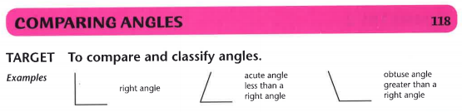
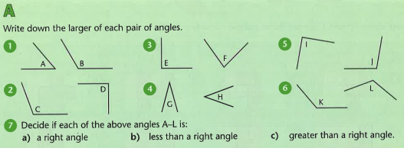
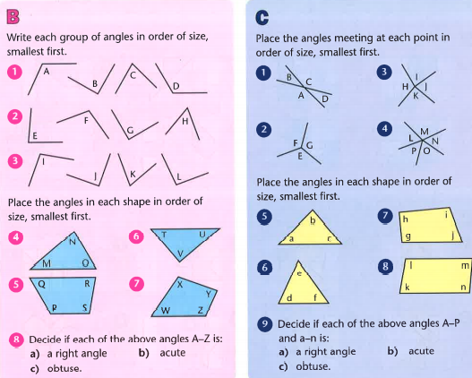

Find the answers below
