Science Year 3 and 4
Go to the following web page: Watch the video all about sound.
https://www.youtube.com/watch?v=3yqB2KFwJCo

Activity
Make your own string telephone
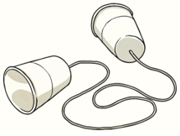

Now write a set of instructions to show how you made your string telephone. Remember to draw pictures/diagrams to show how you did it.

Challenge
Explain why the string had to be pulled tight for the telephone to work?

