Squirrels – English
Year 1
Here is a link to the story, ‘Strictly No Elephants’. Listen to the story again. https://www.youtube.com/watch?v=_0yJOKdvRrg
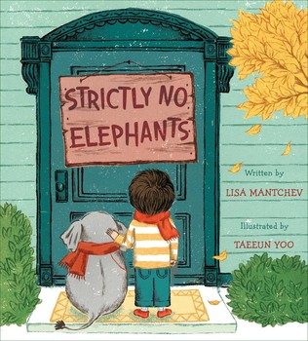
Activity
Here is an example of a story map.
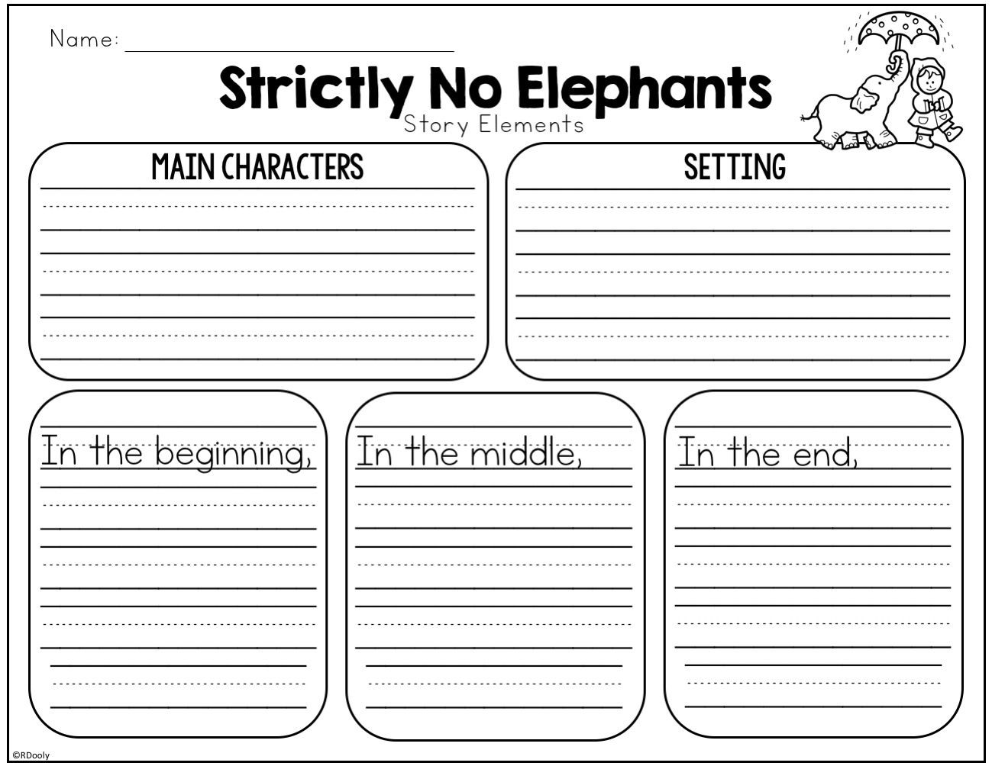

Do you remember the story? Can you fill in this story map?
Challenge
Using your story map can you write a short story retelling what happened?

