Year 1 and 2
Delicious recipes!
Now that the holidays are approaching, here are some fun activities you can do. If you are feeling peckish try the following:
- Cheeky monkey pancakes
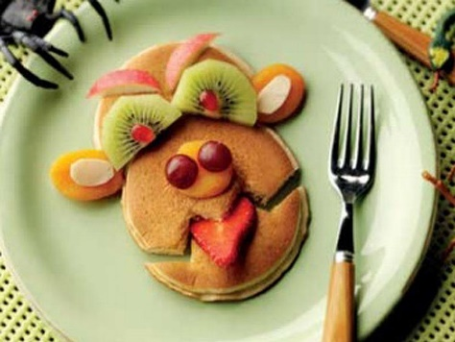
https://www.warburtons.co.uk/cheeky-monkey-pancakes
- Mixed berry French toast
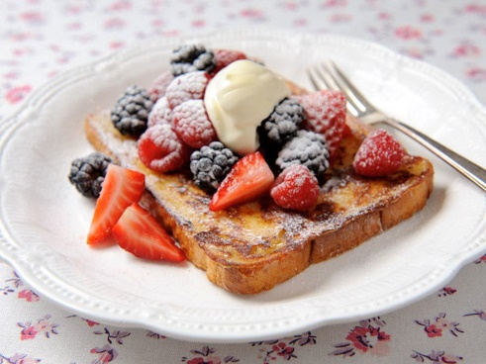
https://www.warburtons.co.uk/mixed-berry-french-toast
- Pizza pockets
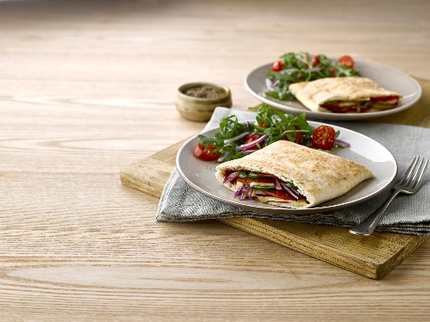
https://www.warburtons.co.uk/pizza-pockets
And there are many many more on this website! Make sure you choose healthy ones and take an adult’s help! Bon appetite!

