Year 2 – computing

Log in to Purple Mash and choose a Maths game that you would like to play.

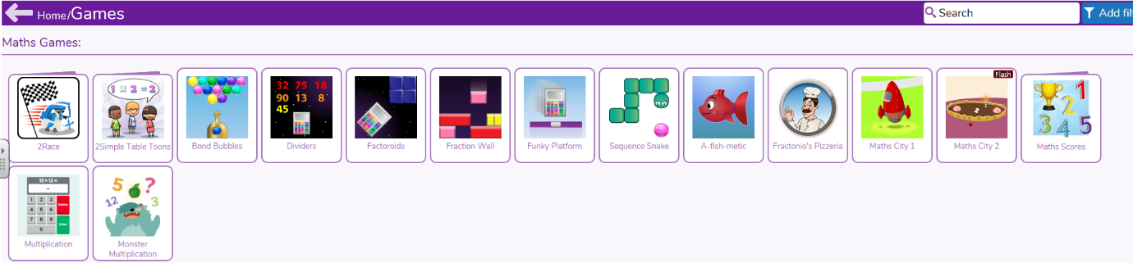
Have fun!

