Year 2 Computing

Log into Purple Mash and create a quiz.
Your quiz can be a general knowledge quiz, or it can be about a specific topic, for example, football, Disney, music, Harry Potter and animals, it is your choice.
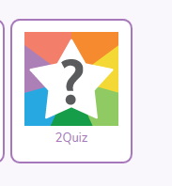
Follow the instructions on Purple Mash to create your quiz.

