Year 2- English
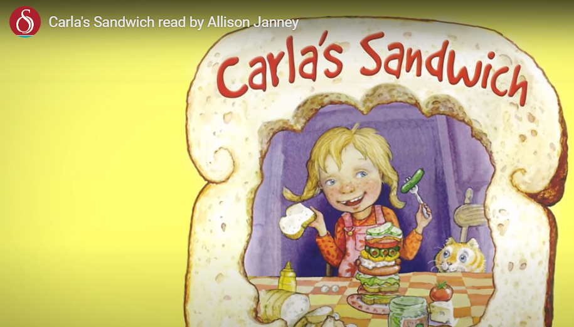
Do you like to eat sandwiches?
If you do, what is your favourite filling?
Watch the story ‘Carla’s Sandwich’ and you will see that Carla likes to eat lots of different and sometimes weird sandwiches.
https://www.storylineonline.net/books/carlas-sandwich/
Task: Write a paragraph to describe your favourite or a very wacky and weird sandwich. You need to be very descriptive because I would like you to make me really want to make one and eat it or make me think that it is completely disgusting and weird!
To do this, you need to use lots of exciting and interesting adjectives. You can use a dictionary and a thesaurus to help you, if you don’t have one at home, you can use one online (see below).
https://www.thesaurus.com/
Can you use an expanded noun phrase? (See below).
https://www.bbc.co.uk/bitesize/topics/zwwp8mn/articles/z3nfw6f

What you need to be successful:
Wow words: peculiar, mouth-watering, flamboyant, juicy, squishy
Golden rules: capital letter, finger space, full stop

Challenge: Can you write a set of instructions to describe how to make your sandwich. You need to include your fantastic descriptions.

