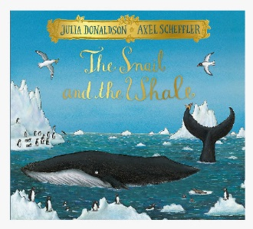
Year 2- English

https://www.youtube.com/watch?v=EmMnaSkeKqQ
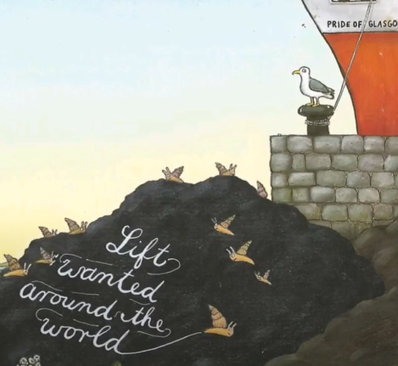
Continue to read the next few pages in the book.
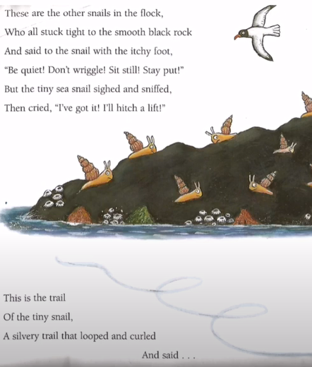
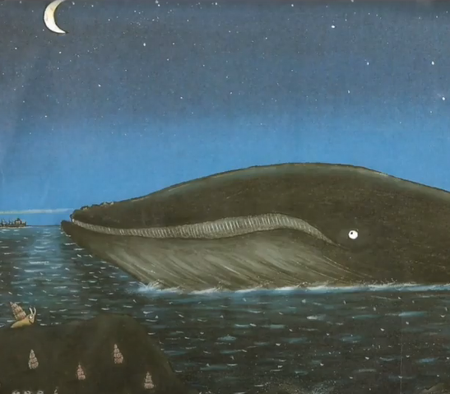

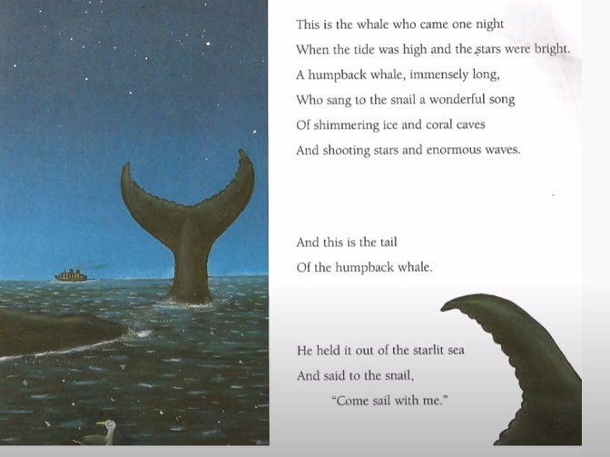
Do you think the snail should go with the whale?

What words does the whale use to convince the snail to go with him?
Does he make the journey sound fun? What adjectives has he used?

Make a list of reasons why the snail should go with the whale and make a separate list of reasons for why the snail should stay.
Which list do you agree with the most?

Task: Write a note to the snail to persuade her to travel with the whale or stay.

You can use this example to support your ideas.

Hello Snail

I strongly believe that you should travel with the whale because you can ride enormous waves and sail across the shimmering ice sea.

I know you have a desire to travel and I believe that you should follow your dreams.

Finally, the whale really wants you to travel with him and he has an immensely long tail which looks like fun.

I hope you follow your dreams.

Miss H.

What you need to be successful:
Wow words: strongly, passionate, convince,
Golden rules: capital letter, finger space, full stop
Interesting sentence openers:
Firstly, I strongly believe…
In addition, …
Lastly,

Challenge:
Can you write a note to the whale and convince him to take you with them? Why should he take you? How could you help them on their journey?

