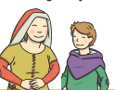
Year 2 English

Read the story of Jack and the Beanstalk and answer the following questions.

Jack and the Beanstalk
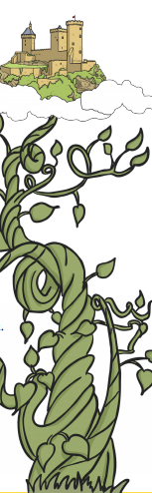
Once upon a time, there was a boy called Jack. Jack lived in a
cottage with his mother. They were very poor and they had a
cow. One day, Jack’s mother asked him to take the cow to market
to sell. On the way, Jack met a man, who gave him
some magic beans in return for the cow.

When Jack came home with the beans his mother was
angry. She threw the beans out of the window and sent him
to bed. The next morning, a giant beanstalk had grown in
the garden! Jack climbed the very tall beanstalk.
When Jack finally reached the top, he saw an
enormous castle. Jack went inside. Suddenly, Jack
heard a loud noise and hid. A huge giant came into
the room with a hen and a golden harp. “Fee, Fi, Fo,
Fum, I smell the blood of an Englishman!” He shouted.
The giant sat down at the table. “Lay!” said the
giant and the hen laid an egg. “Sing!” said the giant.
The harp sang and the giant fell asleep.
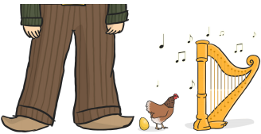
Jack jumped out of the cupboard and took the hen and the harp. As he ran, the harp shouted. The giant woke up and chased Jack.
Jack climbed down the beanstalk and the giant followed
him. As Jack got to the bottom of the beanstalk, he
shouted, “Help!” Jack’s mother came out with an axe. She
used it to chop the bottom of the beanstalk. The giant fell
and crashed to the ground. He was never
seen again. With the golden eggs and the
magic harp, Jack and his mother lived
happily ever after.
Answer the questions below in full sentences.
1. What did Jack sell?
2. What did Jack get in return for the cow?
3. What grew in the garden?
4. How do you think Jack felt when he heard a loud noise?
5. Do you think that the giant is good or bad and how do you know this?
6. How would you react to the giant if you were Jack?
7. Can you think of a different story that is like this one? What are the similarities and differences?

What you need to be successful:
Golden rules: capital letter, finger space, full stop

Challenge: Can you right an alternative ending to the story of Jack and the Beanstalk? You need to use lots of amazing descriptions in your writing to make it exciting.

