Year 2- English https://www.youtube.com/watch?v=EmMnaSkeKqQ
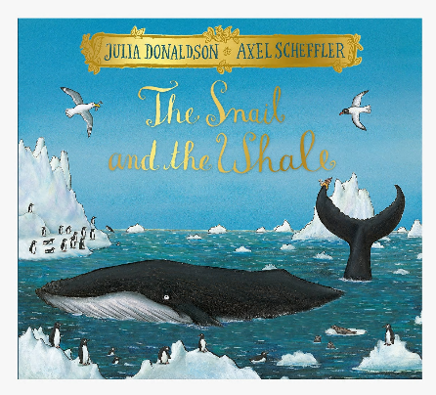
Read the book once again
Book talk
- Was there anything you liked about this story?
- Was there anything that you particularly disliked…?
- Was there anything that puzzled you?
- Were there any patterns…any connections that you noticed…?
- Did it remind you of anything else you’ve read or seen?

Task: Write a postcard from the whale to describe the whale’s adventure.
Where did the whale and the snail travel?
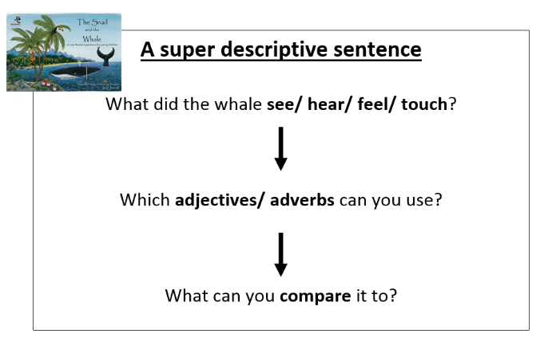
What did they see, hear, smell, feel, and taste whilst they were on their adventure?

What you need to be successful:
Wow words: glimmering, fierce, crashing, sparkling, frightening
Golden rules: capital letter, finger space, full stop
Interesting sentence openers:
As I looked ahead,
Suddenly,
In the distance,

Challenge
If you could travel anywhere in the world, where would you go? If you could pack 5 items what would they be and why?

Here is my postcard, you can use this for ideas.
