Year 2 Geography
Read through the PowerPoint Presentation- Oceans of the World.
Create a leaflet about the Oceans of the world using the information from the PowerPoint.
You need to include facts, colourful pictures and catchy headings.
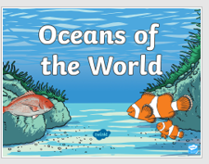
You can create this on Purple Mash (I have set up a 2do) or on paper.

