Year 2 Maths
Multiplication
Children in Year 2 are taught about multiplication and division. They are taught that multiplication is the same as repeated addition - for example 3 x 5 is the same as 5 + 5 + 5 or 3 + 3 + 3 + 3 + 3.
Children often use the concept of ‘arrays’ to help them learn about multiplication. An array is a visual representation of the multiplication process which consists of dots arranged into rows and columns.
Watch the short BBC Bitesize video clip which demonstrates how the use of arrays can help children to learn about multiplication.
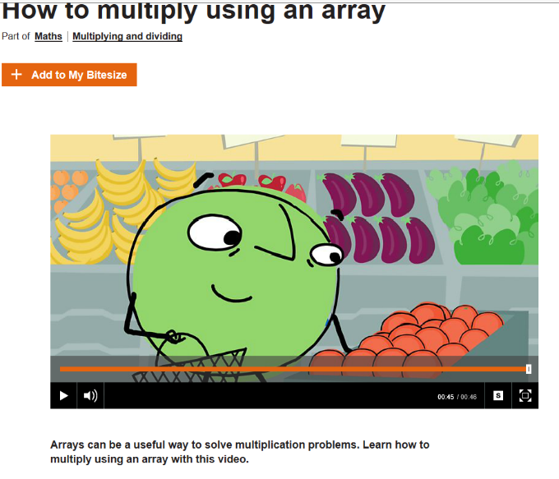
https://www.bbc.co.uk/bitesize/topics/zqbg87h/articles/z3tvcj6

Task.
- Complete the multiplication sentences and use arrays to support your learning (you can draw small dots underneath).

3 x 2 = 4 x 2 = 5 x 2 =

1 x 5 = 3 x 5 = 4 x 5 =

1 x 10 = 2 x 10 = 5 x 10 =

- Write a multiplication sentence for each array.
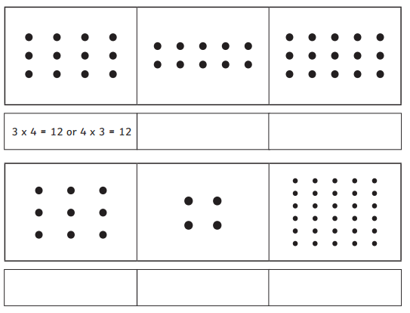
Challenge: 5 x __ = 25

