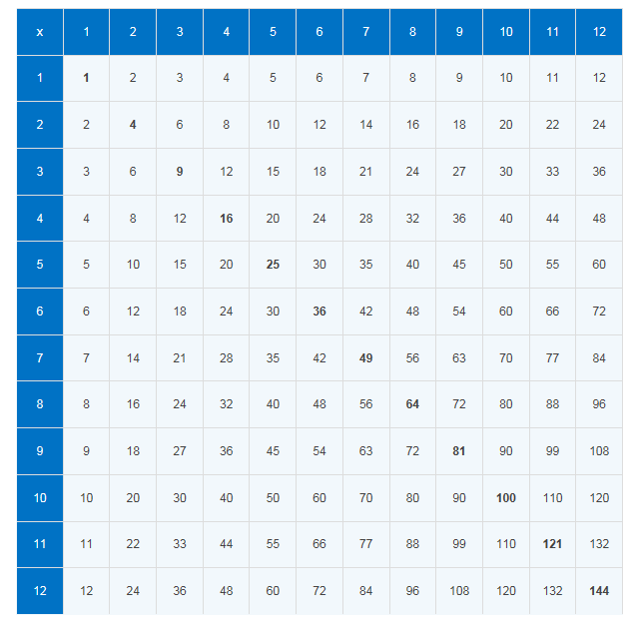
Year 2 Maths
Multiplication: Practise your 2, 5 and 10 times table. You can enlarge the multiplication square to help you practise.

- Complete the multiplication sentences.
- 8 x 2 = b) 9 x 2 = c) 10 x 2 =

d) 7 x 5 = e) 8 x 5 = f) 10 x 5 =

- Can you solve these word problems?
Read the problem carefully, underline the key information, write a number sentence and the then write the answer. The first one has been done for you.

- Six children have 5 biscuits each. How many biscuits are there altogether?
6 x 5 = 30

- Three rabbits have 2 carrots each. How many carrots are there altogether?

- Sam has three 10p pieces in his pocket. How much money does he have altogether?

- A flower has 5 petals. How many petals do 9 flowers have?

- There are five pencils in a pack. Mrs Jones needs 32 pencils. She says, ‘I must buy 8 packs.’ Is she right? Explain your answer.
Challenge: Will there be any left over? If so, how many?

