Year 2 R.E. 03.07.2020
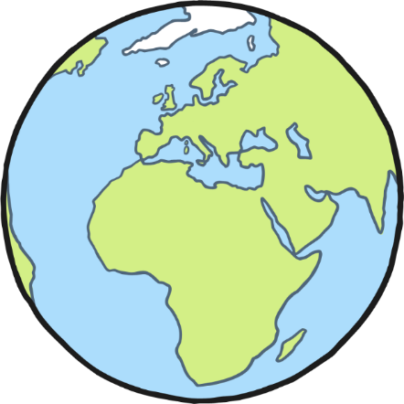
The Creation story is what the Bible says about how the world was created by God.
There are lots of stories from other religions, as well as scientific theories which also explain how the world was created.

Task 1: Look at the Creation Story PowerPoint slides (see below) which describes how God created the world.

Task 2: Can you create a poster to show the Creation Story?
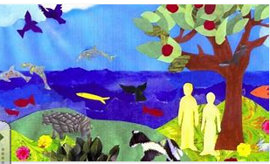
You can get creative and use different art materials, you can draw and write – It is up to you!
If you need some inspiration, look at some of the examples below.
