Year 2 RE

Watch this video clip about how Christians believe that God made the natural world: https://www.bbc.co.uk/bitesize/clips/z62hyrd

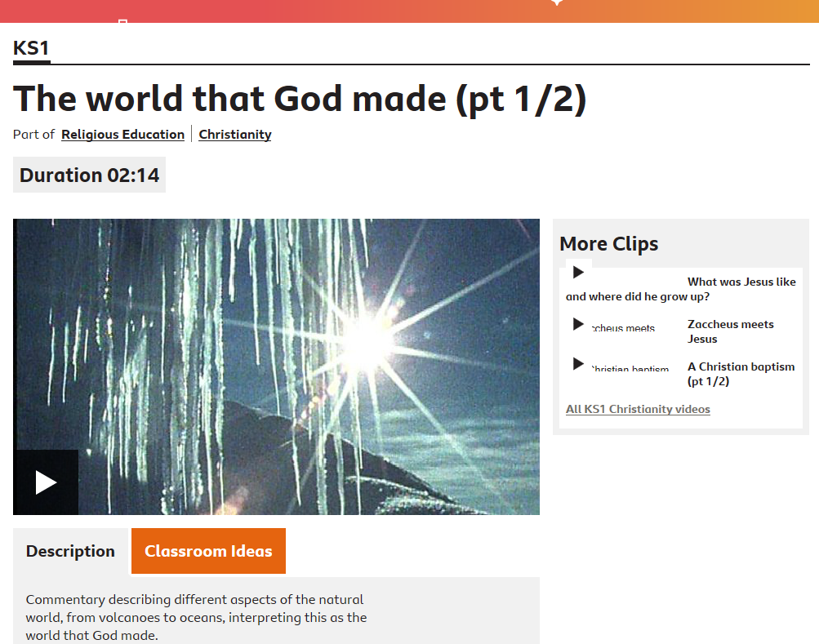
Talk, draw or write about the following questions.

How did this clip make you feel and why?

If you could create something, what would it be and why?

