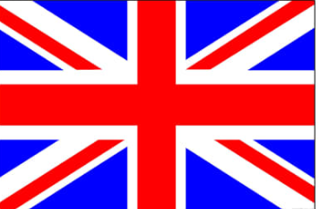
Year 2- Topic

What do you know about the United Kingdom (UK)?

Watch this video to find out more. https://www.bbc.co.uk/bitesize/topics/zyhp34j/articles/z4v3jhv

Can you remember the 4 countries that make up the UK and can you remember their capital cities?
Task: Label the map with the correct countries and capital cities.
If you do not have a printer, you can have a go at drawing and labelling the map yourself.
Challenge: Can you research the flag for each country and colour each box?

