Topic 18.9

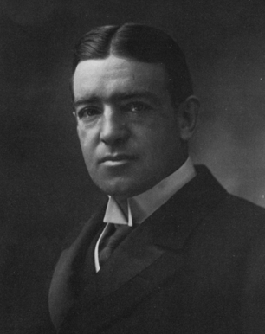 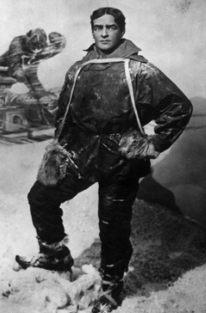

What do you know about Ernest Shackleton?

Use the following words to help you write 2 paragraphs about him.

