Maths 25.09 - Choose some from each section. You don’t need to do all of them.
Choose from A, B or C depending on your confidence.
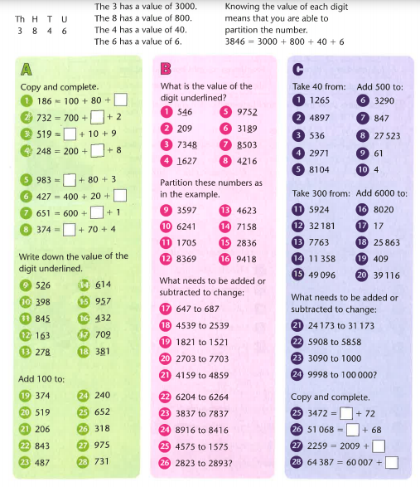

Find the answers below

