**OWLS Maths Homework**

**You must complete at least TWO of these tasks.**

**A**

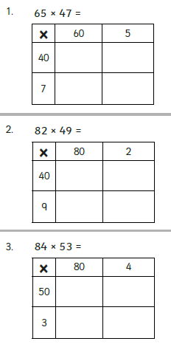 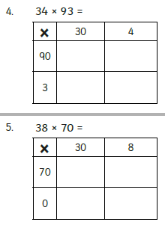

**B**

**Work out using the method of your choice (grid method or long multiplication):**

**  **

**C**

**Work out using the method of your choice (grid method or long multiplication):**



**Challenge**

