Reading comprehension
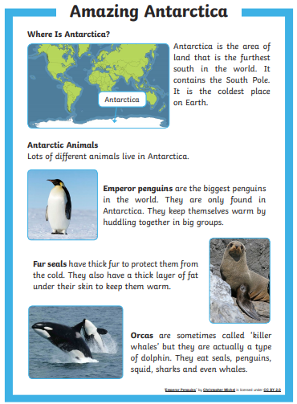
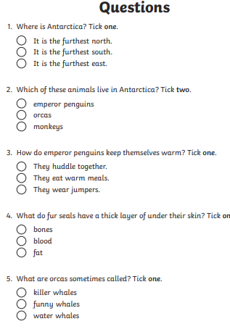

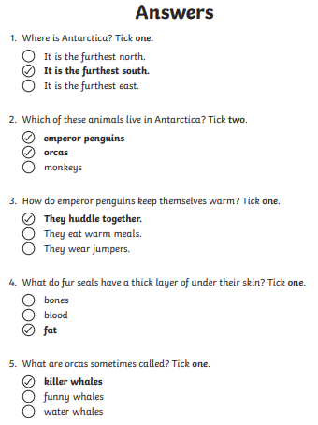

Challenge
Ask your own ’little’ questions (easy one or two word answers) eg what colour is the polar bear?
1)
2)

If you’re feeling really confident ask a ‘big’ question (requires opinion and explanation) eg Would you like to go to the Antarctic? Why?
1)

