Homework - 18.9.20
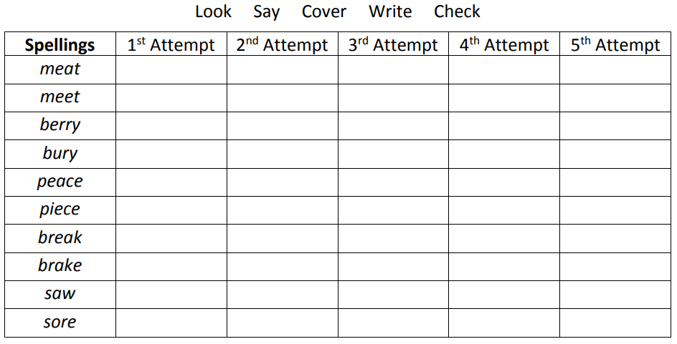
Challenge – Write sentences using these words correctly.

