Spellings 25.9
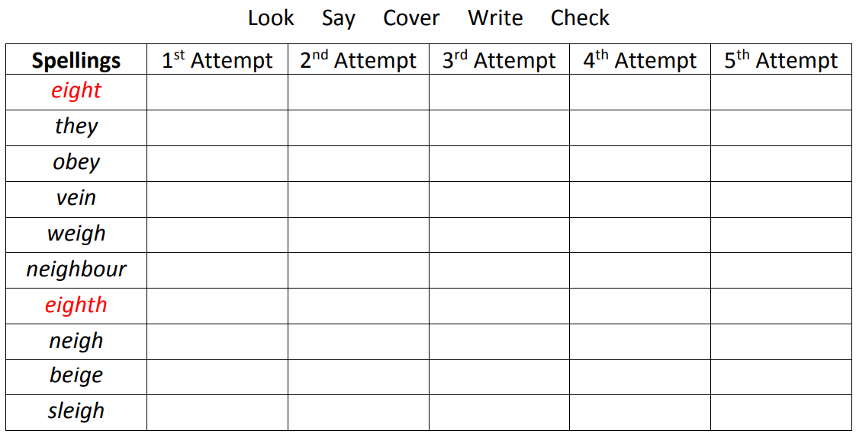
Challenge
determined
courageous
abandon

