Friday 19th September 2020
Squirrels Homework

Hello Squirrels,
A huge well done for another fantastic week. You have all worked so hard! Let’s keep it up for the whole year!

English:
Year 1
Can you go for walk or go into your garden and see if you can answer these questions.

- What can you see?
- What can you hear?
- What can you taste?
- What can you smell?
- What can you touch?

Year 2
Can you go for walk or go into your garden and see if you can answer these questions.

- What can you see?
- What can you hear?
- What can you taste?
- What can you smell?
- What can you touch?

Try to add lots of adjectives into your work. Think about ways to describe what you see, taste, hear, touch and smell.

For example,
I can see some colourful birds that are flapping around the beautiful trees.

Maths:
Year 1
1. Can you find the missing numbers going forwards on the number line?
2. Can you find the missing numbers going backwards on the number line?
3. Can you write down what one more than 6 is?
4. Can you write down what one less than 9 is?

Year 2
1. Can you compare these numbers using these signs?
12 17
76 33
21 21

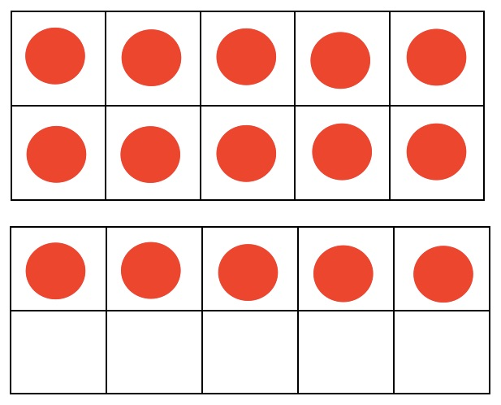
2. Can you work out what number this tens frames show?

Challenge:
3. Can you represent these numbers in the tens frames?
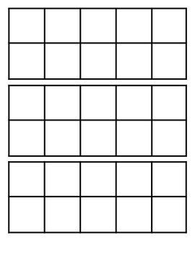

36

25

