Squirrels Homework – 25.09.2020

English
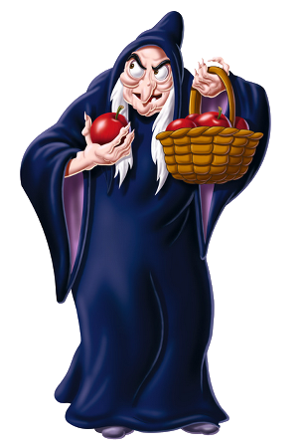
Have a look at the following characters from Traditional Tales:
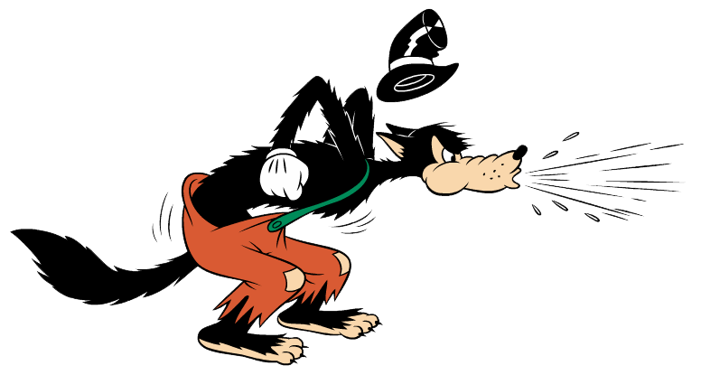
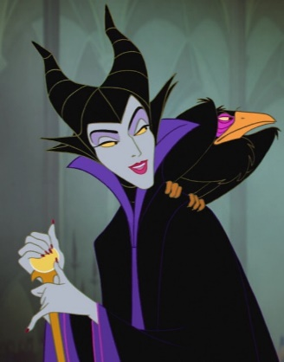

Maleficent The Big Bad Wolf The Evil Step Mother

What do they all have in common?
Can you think of some other villains from traditional tales?

Year 1:
Think of a villain from a Traditional Tale.
Draw a picture of the Villain and write their name underneath.
Challenge:
Write a sentence about what they did in the Traditional Tale that made them a villain.

Year 2:
Think of a villain from a Traditional Tale.
Draw a picture of the Villain and write their name underneath.
Write a sentence about what they did in the Traditional Tale that made them a villain.
Challenge:
Can you write some adjectives that describe your villain? Try and write 5 adjectives around the picture of the villain.

Maths
This week, we have been learning about comparing numbers and ordering numbers. Please complete the activities below according to your year group.
Year 1:
1, Fill in the missing numbers:

2. Use the Alligators to compare the numbers:

Year 2:
- Fill in the missing numbers:

- Use the Alligators to compare the numbers:

