25th September 2020
The Badgers have had another fantastic week. Well done everyone. Please see the maths homework below and remember to find your spellings on Purple Mash and to read for at least 10 minutes daily.
Great work everyone!

Maths Homework
1.
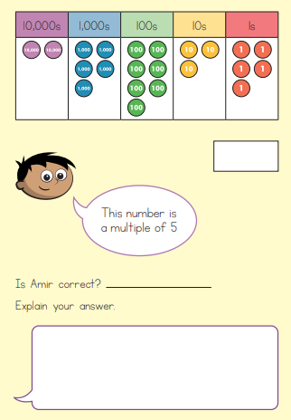

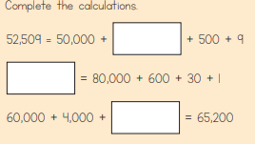

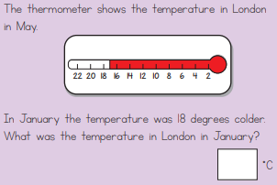

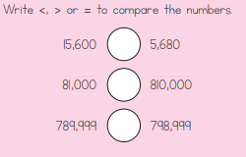

And if you fancy a challenge:

