Verbs 15.10

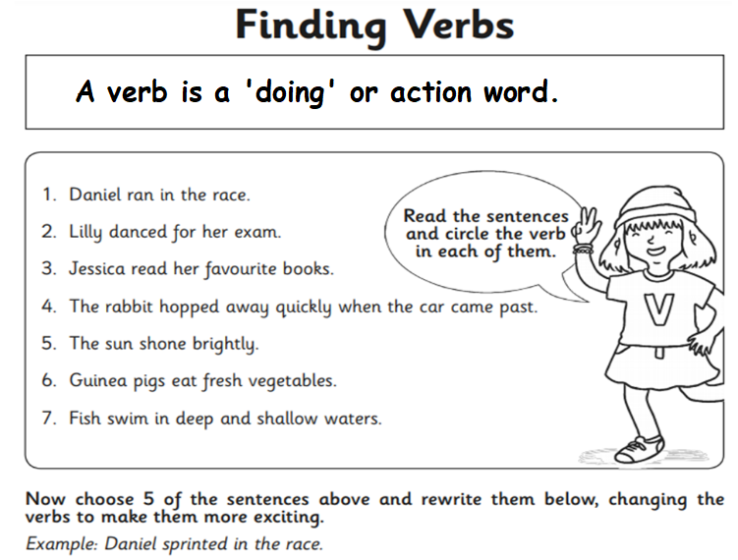

How many verbs can you think of?

1.

2.

3.

4.

5.