English 8.10

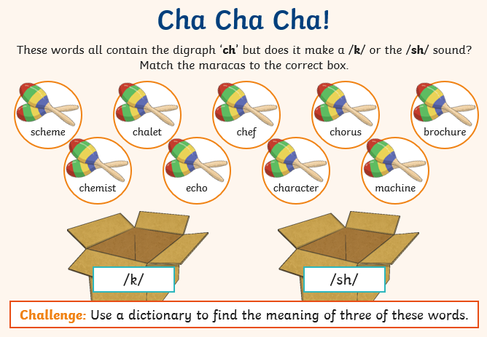

Can you put these words into chronological order?

