October Half Term Project
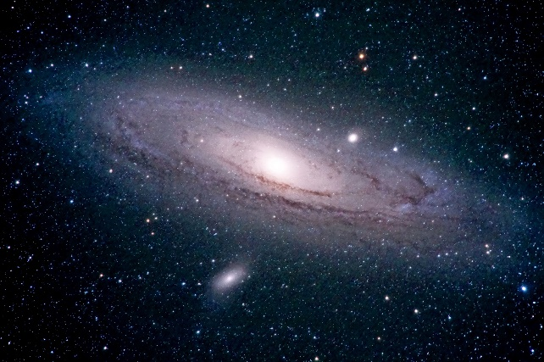
Next term we are learning all about space. This includes the solar system, stars, wondering how we know the earth isn’t flat, how do rockets work. We will even be asking some big questions such as ‘Will we ever live on Mars?’ and ‘Is there life out there somewhere?’
So over half term I’d love it if you could complete one of the mini projects below:
- Write a fact file about a particular planet.
- Make a mini model of the solar system.
- Go outside at night and spot constellations, tell me what you see.
- Write a news report pretending you’re an astronaut from the International Space Station.
- Video yourself walking on the moon and reporting back to NASA.
- Research your favourite astronaut.
- Write a story pretending you’re an alien and you’ve landed on earth.
Good luck on your mission! We look forward to welcoming you back to planet Charing School in November.

