Friday 16th October 2020
Squirrels Homework
A huge well done for a fantastic first term Squirrels! You have worked so hard and you have done brilliantly!

English (Year 1 and 2)
Please have a go at the ‘Castles Wordsearch’ below. This is a fun activity to finish off our topic for the term! You have all shown such enthusiasm in this topic, so really well done!
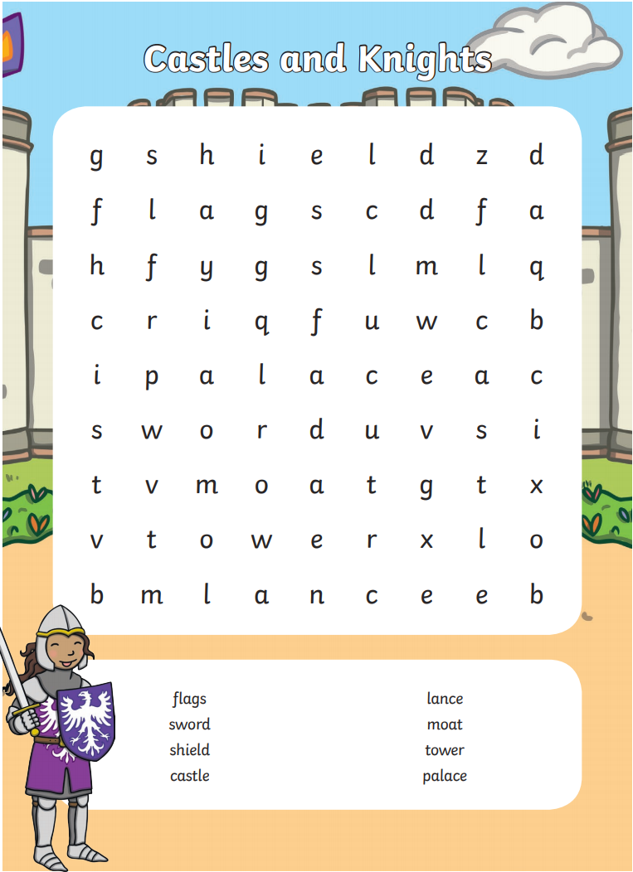

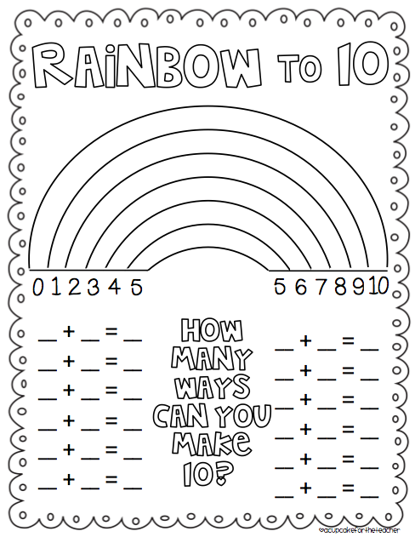
Year 1 Maths – We have really concentrated on part whole models throughout this term. Please have a go at finding the different number bonds to 10 on the rainbow below. Colour in each section of the rainbow and write down the number sentences that make 10.
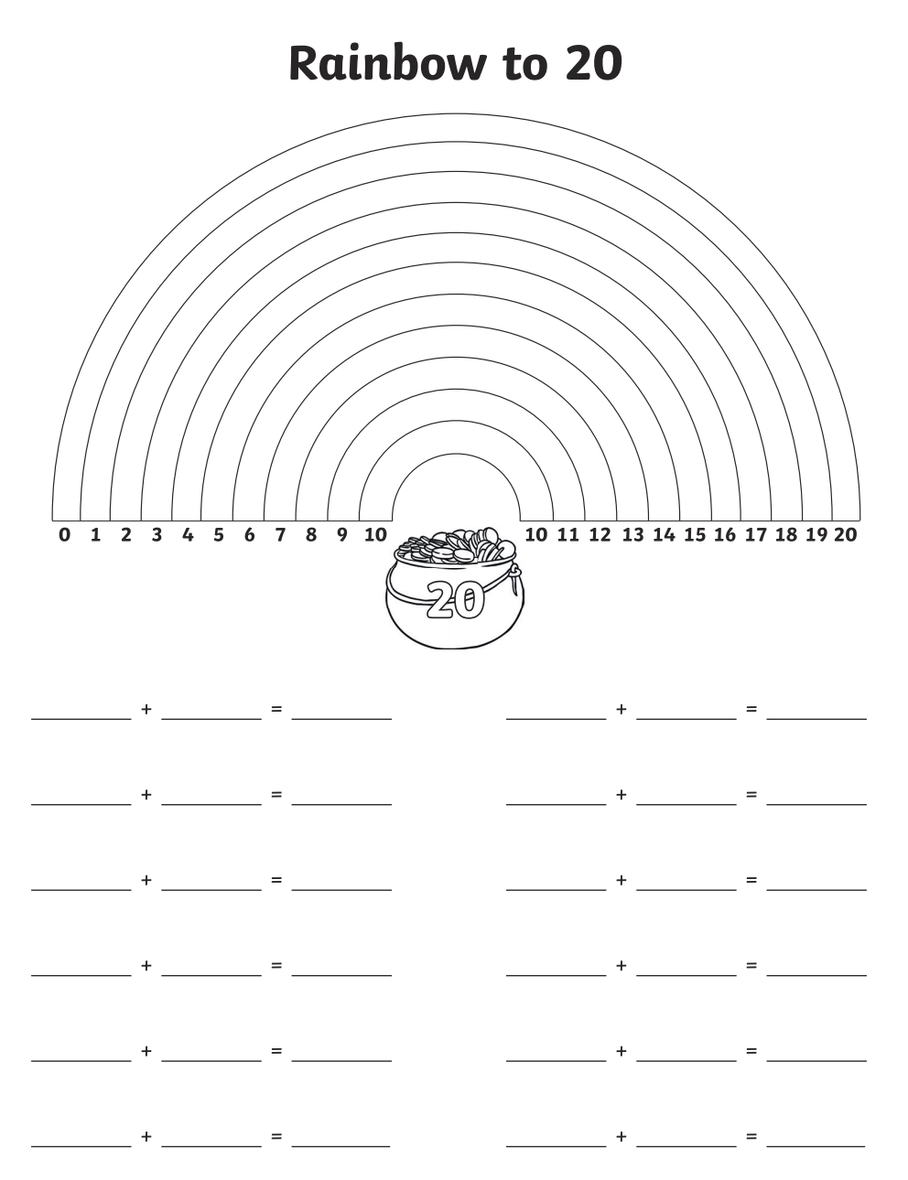
Year 2 Maths – We have really concentrated on part whole models throughout this term. Please have a go at finding the different number bonds to 20 on the rainbow below. Colour in each section of the rainbow and write down the number sentences that make 20.

